POPE FRANCIS
PRAYER FOR YOUNG PEOPLE IN VIEW OF THE FORTHCOMING SYNOD OF BISHOPS 2018:
“Young people, faith and vocational discernment”
Lord Jesus, in journeying towards the Synod, your Church turns her attention to all the young people of the world. We pray that they might boldly take charge of their lives, aim for the most beautiful and profound things of life and always keep their hearts unencumbered. Accompanied by wise and generous guides, help them respond to the call you make to each of them, to realize a proper plan of life and achieve happiness.
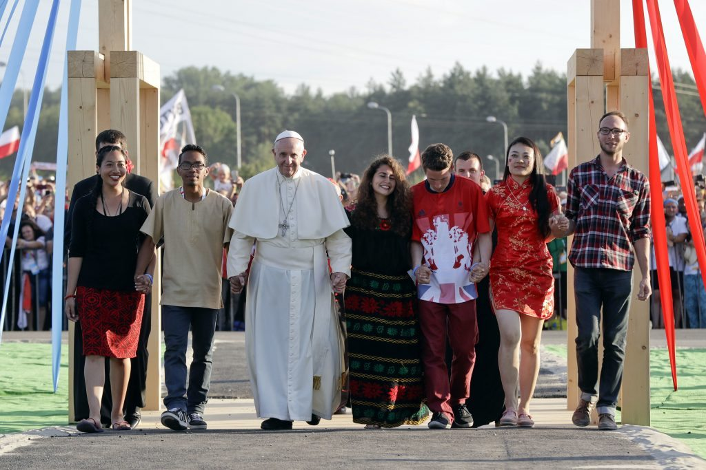
Keep their hearts open to dreaming great dreams and make them concerned for the good of others. Like the Beloved Disciple, may they stand at the foot of the Cross, to receive your Mother as a gift from you. May they be witnesses to your Resurrection and be aware that you are at their side as they joyously proclaim you as Lord. Amen.

POPE FRANCIS
PRAYER FOR YOUNG PEOPLE IN VIEW OF THE FORTHCOMING SYNOD OF BISHOPS 2018:
“Young people, faith and vocational discernment”
Lord Jesus, in journeying towards the Synod, your Church turns her attention to all the young people of the world. We pray that they might boldly take charge of their lives, aim for the most beautiful and profound things of life and always keep their hearts unencumbered. Accompanied by wise and generous guides, help them respond to the call you make to each of them, to realize a proper plan of life and achieve happiness.
Keep their hearts open to dreaming great dreams and make them concerned for the good of others. Like the Beloved Disciple, may they stand at the foot of the Cross, to receive your Mother as a gift from you. May they be witnesses to your Resurrection and be aware that you are at their side as they joyously proclaim you as Lord. Amen.

